
Mini Project Report
On
Google Play Store Analysis
Course: DATA VISUALIZATION
Course Code: CAP483
Submitted by  Name: Ananya Tripathi  Reg: 12100709  Roll No: A01  Section: DE443 | Submitted to  Dr. Logeswari P  Assistant Professor  SCA, LPU

School Of Computer Applications
Lovely Professional University
Punjab
2023-2024 (Term 1)
Abstract
The "Google Play Store" dataset is a collection of data related to mobile applications available on the Google Play Store. It encompasses various attributes that provide valuable insights into app listings. The dataset consists of the following columns:
- App: The name of the mobile application.
- Category: The category to which the app belongs.
- Rating: The user rating of the app.
- Reviews: The number of user reviews for the app.
- Size: The size of the app in terms of storage.
- Installs: The number of times the app has been installed.
- Type: The type of app, whether it's free or paid.
- Price: The price of the app (if it's a paid app).
- Content Rating: The age group for which the app is appropriate.
- Genres: The genres or tags associated with the app.
- Last Updated: The date when the app was last updated.
- Current Ver: The current version of the app.
- Android Ver: The minimum Android version required to run the app.

This dataset is valuable for performing various analyses and visualizations to understand trends in the Google Play Store, such as the distribution of apps across categories, the relationship between user ratings and installs, and the prevalence of free versus paid apps. By leveraging Tableau's visualization capabilities, I have gained deeper insights into the mobile app ecosystem and make data-driven decisions related to app development and marketing strategies.
Keywords used in the report Amazon sales dataset:

- App: The name of the mobile application.
- Category: The category or genre to which the app belongs (e.g., Games, Productivity).
- Rating: The user-generated rating or review score for the app (e.g., 4.5 stars).
- Reviews: The number of user reviews or feedback for the app.
- Size: The amount of storage space the app occupies on a device.
- Installs: The count of how many times the app has been downloaded and installed.
- Type: Indicates whether the app is free or paid.
- Price: The cost of the app (if it's a paid app).
- Content Rating: The age group or audience for which the app is suitable (e.g., Everyone, Teen).
- Genres: Specific tags or genres associated with the app (e.g., Puzzle, Adventure).
- Last Updated: The date when the app was last updated.
- Current Ver: The version number of the app's most recent release.
- Android Ver: The minimum Android operating system version required to run the app.
- Tableau: The data visualization software used for creating interactive and shareable dashboards.
- Data Visualization: The graphical representation of data to help people understand its patterns, trends, and insights.
- Dashboard: A consolidated view of data and visualizations that provides a summary of key information.
- Charts: Visual representations like bar charts, line charts, scatter plots, and pie charts used to display data.
- Data Analytics: The process of examining and interpreting data to draw conclusions and make data-driven decisions.
- Data Exploration: The initial phase of data analysis where data is examined to understand its structure.

List of figures/charts

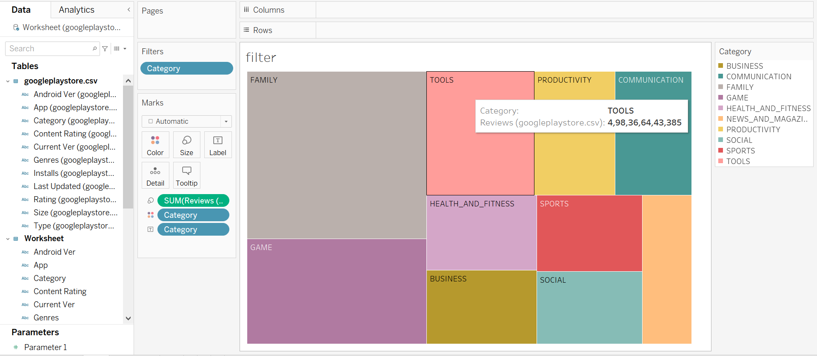

Fig 1. Result after using FILTER Option

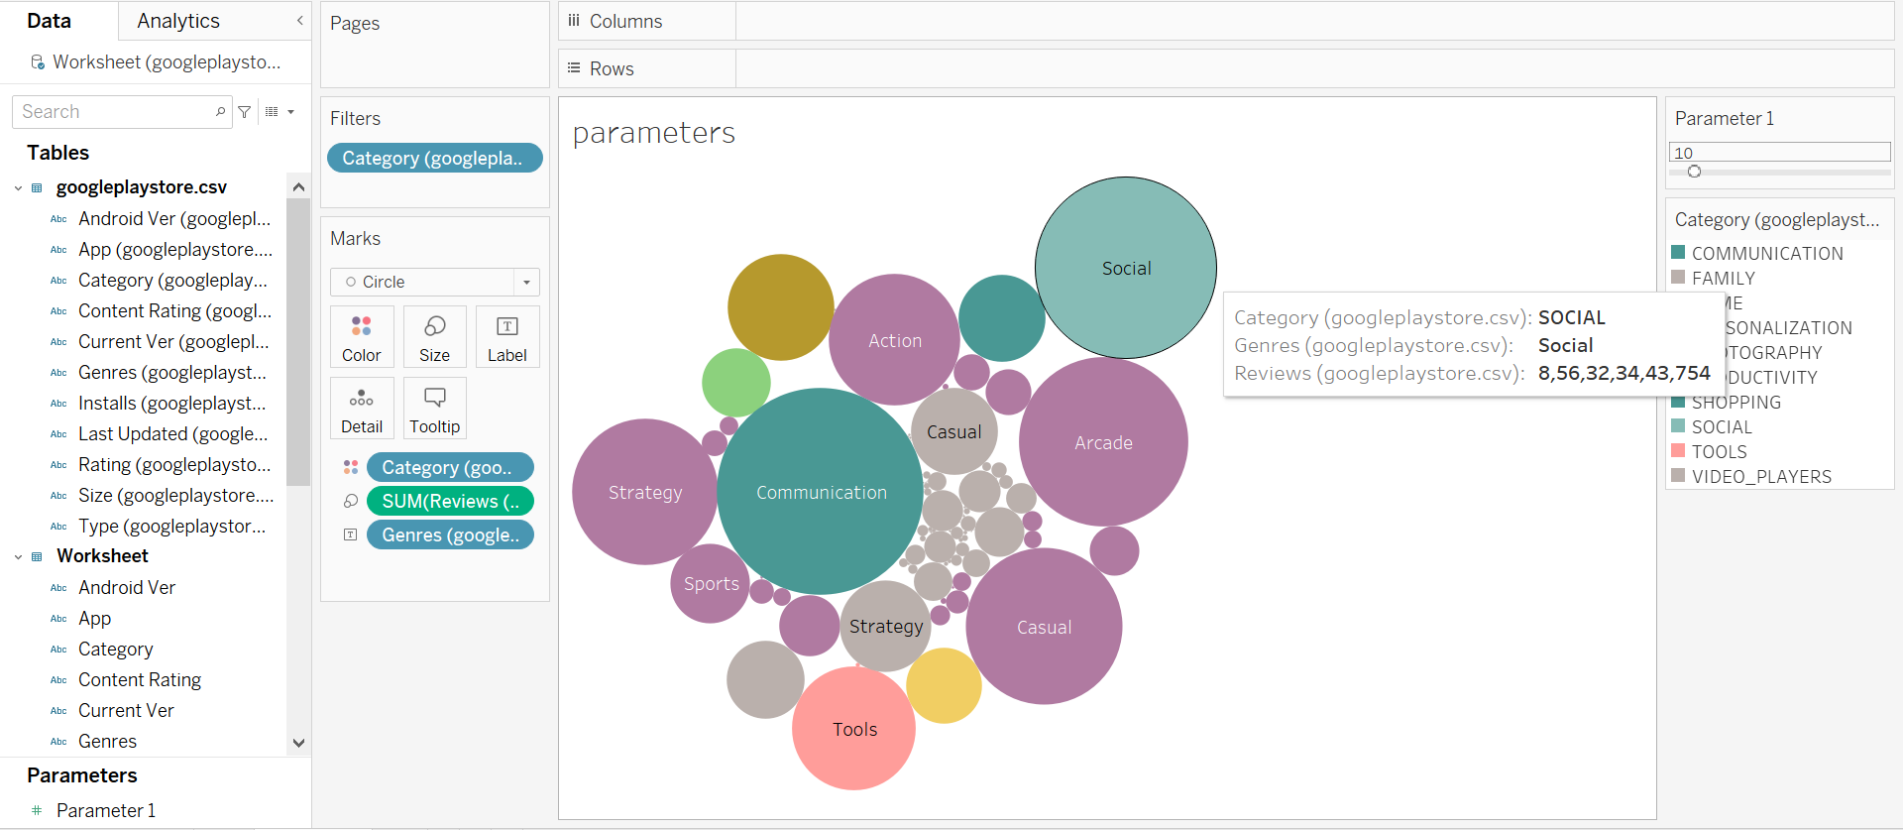

Fig 2. Result after using PARAMETER Option

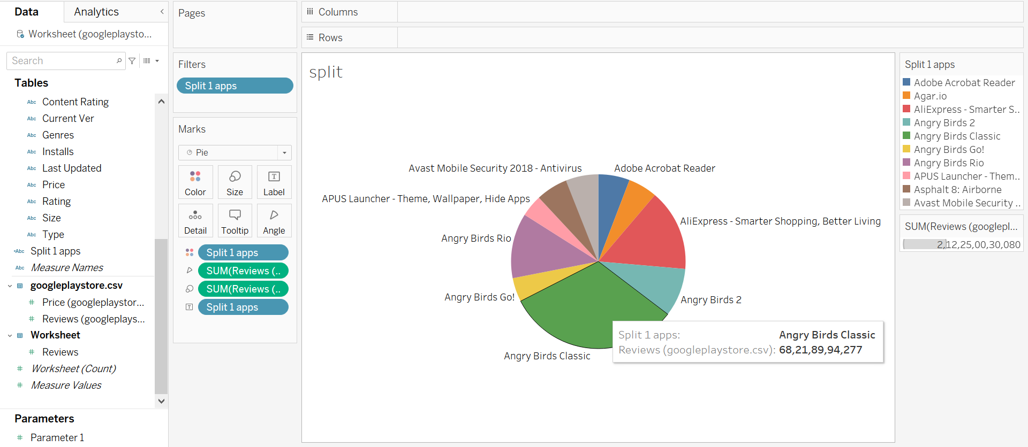

Fig 3. Result after using SPLIT Option and splitting the app column

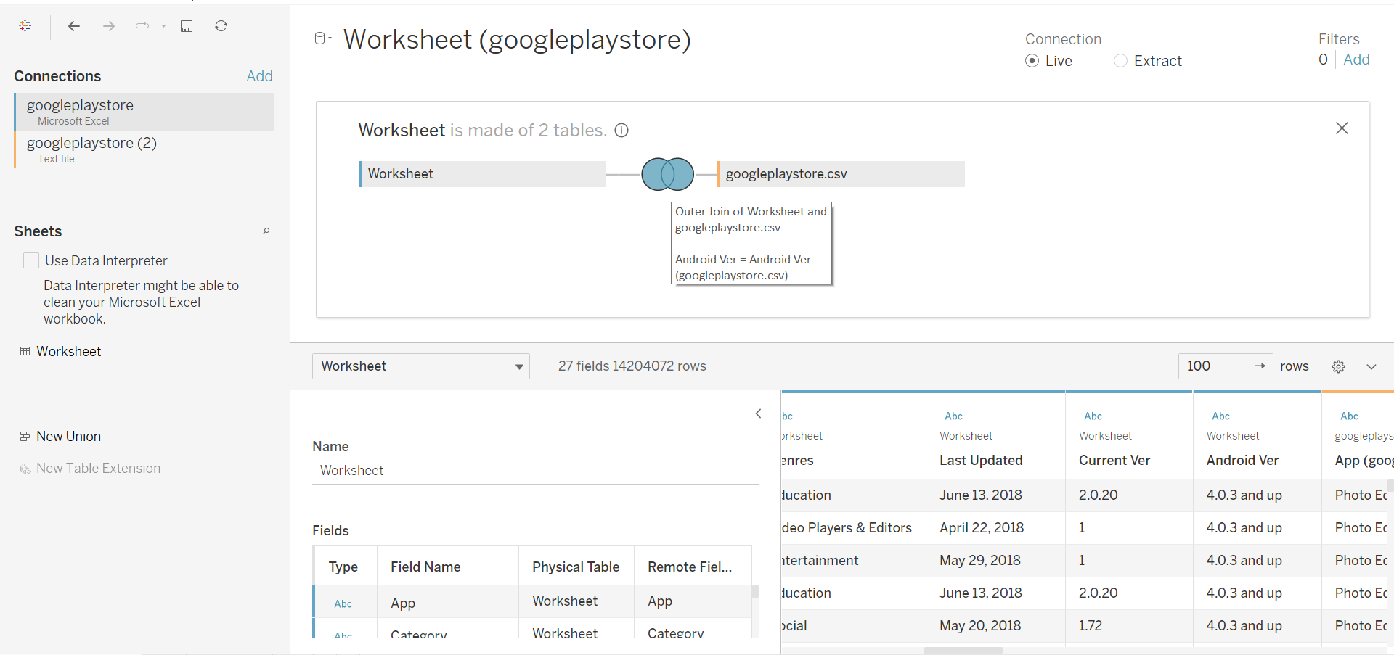

Fig 4. This Fig is showing Joins of two datasets

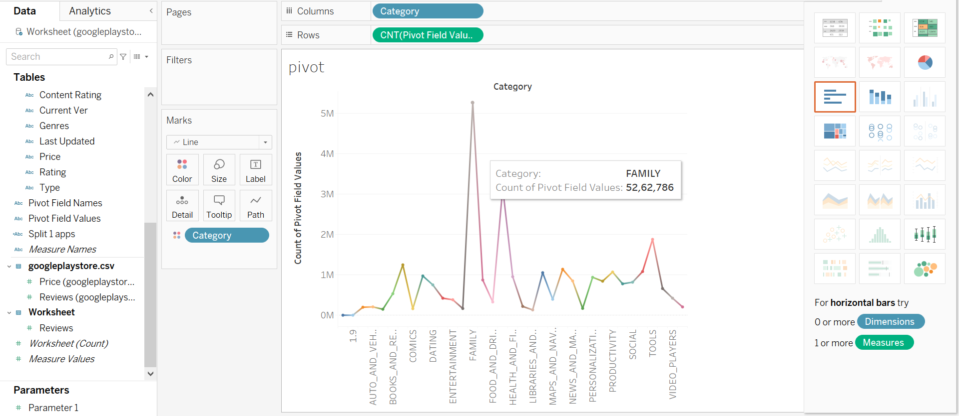

Fig 5. Result after applying PIVOT option
List of Techniques used

In the analysis of the Google Play Store dataset, a variety of techniques were used to preprocess, explore, and visualize the data. Here is a list of some of the key techniques applied in the project:
1. Data Preprocessing:
- Data cleansing to remove unwanted characters from column.
2. Data Visualization:
- Treemaps: This technique is used to represent hierarchical data structures and display the hierarchical structure of data in a nested, rectangular form
- Line Charts: Depicting time-series data to reveal sales trends over time.
- Packed Bubbles: Type of data visualization that is used to display hierarchical or grouped data in a circular or nested format
- Box Plot: Analyzed the distribution of car prices based on different transmission types.
- Dashboards in Tableau are composed of various elements, including worksheets, charts, filters, and text.
3. Descriptive Statistics: Measures of central tendency (mean, median, mode) and measures of dispersion (range, variance, standard deviation, interquartile range) were calculated to summarize data characteristics.
4. Data Exploration: Basic exploration of the dataset's dimensions and structure to understand its size and attributes.

Table of Content
Sr. No. | Particulars | Page No.
 | Introduction
 | Objectives
 | Statement of Analytical Tasks implemented
 | Implementation of the Project
 | Results and Discussion
 | Conclusion

Introduction

In an era where mobile applications have become an integral part of our daily lives, the Google Play Store stands as one of the most prominent platforms for discovering and downloading apps. With millions of apps available across diverse categories, it has not only transformed the way we interact with technology but also presented a treasure trove of data waiting to be explored and understood.
The Google Play Store dataset offers a rich source of information about these applications. From the categories they belong to, user ratings, and installation statistics to pricing models and content ratings, this dataset encapsulates a comprehensive snapshot of the app ecosystem. However, to make sense of this data and unlock its insights, I have used the power of data visualization and analysis tools.
Tableau is a robust data visualization platform that empowers analysts and data enthusiasts to dig deep into datasets, uncover hidden patterns, and communicate meaningful insights. In this exploration, I harness the capabilities of Tableau to transform raw data into dynamic, interactive visualizations that not only provide a clear understanding of the Google Play Store landscape but also enable data-driven decision-making.
Throughout this journey, I will navigate through various facts of the Google Play Store data, from understanding the distribution of apps across categories to examining the correlation between user ratings and installs. With Tableau I will create informative dashboards, charts, and graphs that breathe life into the data, making it accessible and actionable for developers, marketers, and decision-makers alike.
So, fasten your seatbelts as we embark on an exciting journey into the world of Google Play Store data analysis with Tableau, where insights are just waiting to be discovered and leveraged for better app development, marketing strategies, and a deeper understanding of the app ecosystem.

Objective
Comprehensive Data Exploration: To thoroughly explore and understand the Google Play Store dataset, examining its various dimensions, including categories, ratings, installations, and pricing. Visualization Mastery: To demonstrate proficiency in using a variety of Tableau visualization techniques, such as tree maps, bubble charts, line charts, and box plots, to represent and communicate insights effectively.

Category Insights: To provide insights into the distribution of apps across different categories and genres on the Google Play Store, identifying trends and popular segments. User Behavior Analysis: To analyze user behavior by exploring correlations between user ratings, the number of reviews, and app installations, leading to a deeper understanding of what drives app popularity.

Outlier Detection: To identify and analyze outliers within the dataset, especially concerning app ratings and reviews, to understand exceptional cases and their potential impact. Statistical Insights: To employ box plots to provide statistical insights, including the median, quartiles, and potential outliers for relevant metrics, offering a more comprehensive understanding of the data's distribution.
User Engagement: To engage the audience through interactive Tableau visualizations, allowing users to explore and interact with the data, fostering a deeper understanding of the insights presented.
Project Documentation: To document the data analysis process, data sources, methodology, and Tableau techniques used, ensuring the project's reproducibility and transparency.
Knowledge Sharing: To share the project's findings, insights, and Tableau dashboards with relevant stakeholders or the broader community, promoting knowledge dissemination and facilitating informed decision-making.
These objectives will guide your project and help you stay focused on the goals of analyzing Google Play Store data effectively using Tableau. They also provide a clear direction for the analysis and visualization tasks ahead.

Statement of Analytical Tasks Implemented

1. Data Exploration:
- Initial exploration of the dataset's dimensions to understand its size and structure.
2.Data Preprocessing:
- Handling Missing Data: Identified and addressed missing values to ensure data integrity.
- Data Cleansing: Remove unwanted characters, specifically the "Ã©" character from the column.
- Data Type Standardization: Converted data types to ensure consistency, including the conversion of app, Category, Rating, Reviews, Size, Installs, Type, Price, Content, Rating Genres, Last Updated, Current Ver, Android Ver.
3. Data Visualization:
- Heatmaps
Purpose : Heatmaps are powerful tools for visualizing the distribution and intensity of data values within a matrix. They are often used to identify patterns, trends, and correlations in large datasets.
Color Gradients : Heatmaps use a color gradient to represent values, with colors ranging from low (e.g., cool colors like blue) to high (e.g., warm colors like red). This allows users to quickly spot areas of interest.
Applications : Heatmaps are commonly employed in various fields, including finance (stock price movements), biology (gene expression), and web analytics (user engagement heatmaps).

- Line Charts
Purpose : Line charts are ideal for displaying time-series data, showing how a variable changes over time. They are effective at revealing trends, fluctuations, and seasonality in data.
Data Points and Lines : Each data point represents a value at a specific time, and lines connect these points to visualize the data's progression.
Interactivity : In interactive line charts, users can often hover over points to see precise values or zoom in on specific time intervals.
Applications : Line charts are widely used in finance (stock price history), weather forecasting (temperature trends), and marketing (website traffic over time).

- Packed Bubbles
Purpose : Packed bubbles, also known as bubble maps, are used to illustrate hierarchical or grouped data in a circular or nested format. Larger bubbles encompass smaller bubbles, conveying relationships and proportions.
Hierarchy : The outermost bubble represents a higher-level category or group, while inner bubbles represent subcategories or elements. The size of each bubble indicates its value or significance.
Applications : Packed bubbles are often used in data journalism to visualize complex topics like population demographics, organizational structures, or product hierarchies.
- Box Plot
Purpose : Box plots, also known as box-and-whisker plots, display the distribution of a dataset. They show the median, quartiles, and potential outliers in a compact visual format.
Components : A box plot typically consists of a box (interquartile range) and "whiskers" (minimum and maximum values within a range).
Outliers : Outliers, if present, are plotted as individual points beyond the whiskers, helping to identify extreme data points.
Applications : Box plots are valuable in fields like economics (income distribution), healthcare (patient test results), and data quality assessment.

- Dashboards in Tableau
Components : Tableau dashboards combine various elements, including worksheets (visualizations), charts, filters (for interactivity), and text (for annotations and explanations).
Interactivity : Dashboards enable users to interact with visualizations, filter data dynamically, and gain deeper insights by exploring different aspects of the data.
Customization : Designers can customize dashboard layouts, fonts, colors, and interactive elements to create user-friendly, informative, and aesthetically pleasing displays.
Sharing : Once created, Tableau dashboards can be shared with others, allowing stakeholders to access and explore the data-driven insights.

These data visualization techniques and elements play critical roles in turning raw data into meaningful insights, facilitating data-driven decision-making across various domains and industries.
Implementation of the Project
Now we are going to see the steps of the charts which I have made one by one:

- Tree Map:
Steps to create Tree Map:
  - First drag the item type on rows and Units sold measure on text in Marks area, you will see the table view
  - Now from Show Me option on right top corner select the TreeMap graph to convert table from Table to TreeMap chart
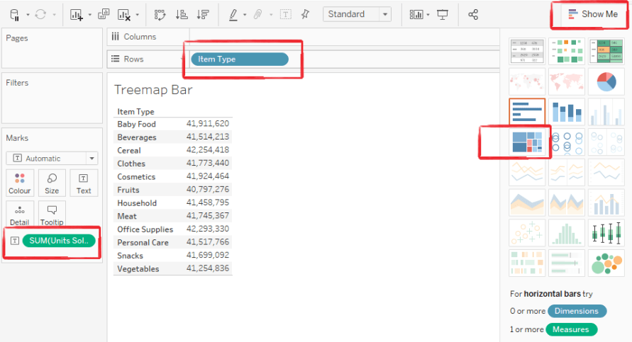
  - Below will be the converted chart into TreeMap
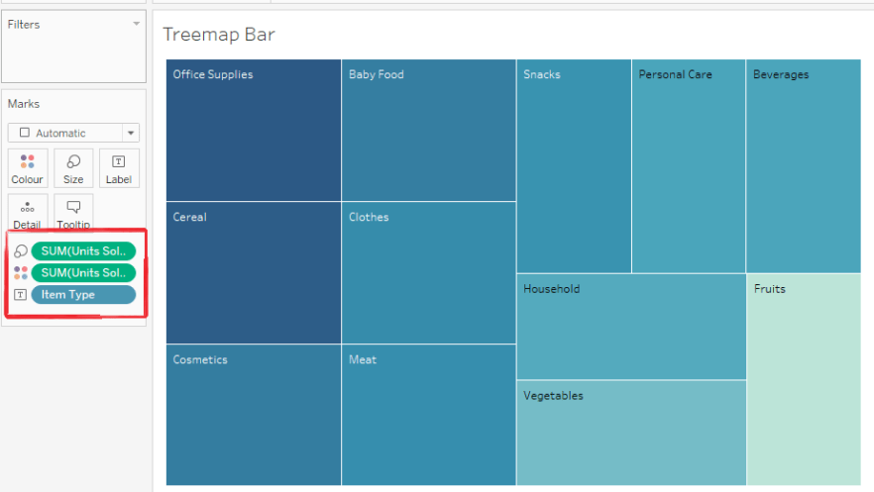
  - You can change the colours of Item Type by dragging the Items on Colours Marks and the change colours pallet from colours option
  - You can also drag the Item Type on Text option in Marks Area to see each item in Rectangle boxes
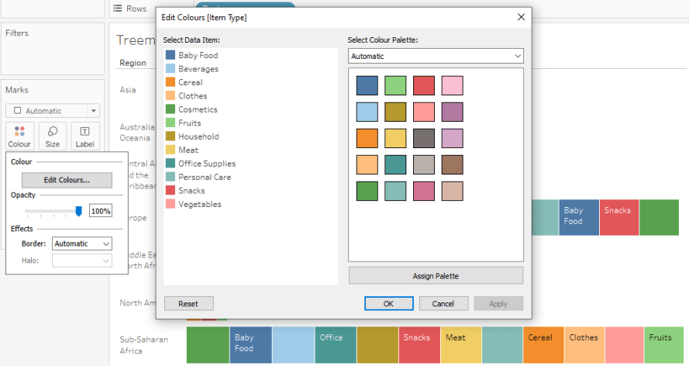
  - You can also drag the “Units Sold” on Text option in Marks Area to see each value of Units Sold for each item type in Rectangle boxes
  - Finally, below will be the Colourful TreeMap Bar Chart in Tableau

Parameter : Creating the parameters
- In the Data pane, click the drop-down arrow in the upper right corner and select Create Parameter.
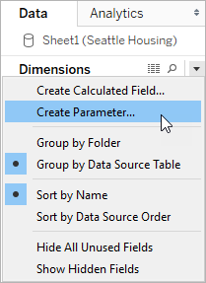
- In the Create Parameter dialog box, give the field a Name.
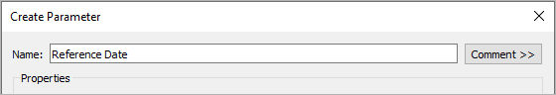
- Specify the data type for the values it will accept:
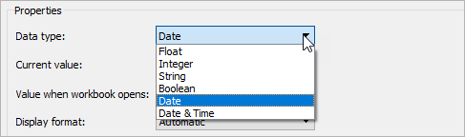
- Specify a current value. This is the default value for the parameter. In this case, let’s leave the field as is because we’ll be using the latest data, which we’ll configure in the next step.
- Specify a value when the workbook opens. In this case, let’s create a dynamic parameter by setting the parameter’s default value to the result of a single-value, view-independent calculation.
For this dynamic parameter, let's use Latest Month. This means that if the connected data source is updated and the workbook is opened, the parameter will automatically update when the workbook is opened.
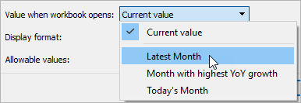
- Specify the display format to use in the parameter control (Tableau Desktop only).
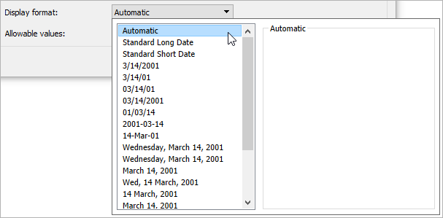
- Specify how the parameter will accept values. You can select from the following options:
  - All - The parameter control is a simple text field.
  - List - The parameter control provides a list of possible values for you to select from.
  - Range - The parameter control lets you select values within a specified range.
The availability of these options is determined by the data type. For example, a string parameter can only accept all values or a list. It does not support a range.
If you select List, you must specify the list of values. Click in the left column to type your list of values, or you can add members of a field by selecting Add values from.
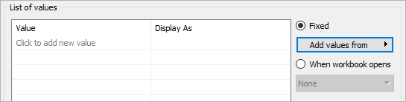
If you select Range, you must specify a minimum, maximum, and step size. For example, you can define a date range between January 1, 2019 and December 31, 2019, with the step size set to 1 month to create a parameter control that lets you select each month in 2019.
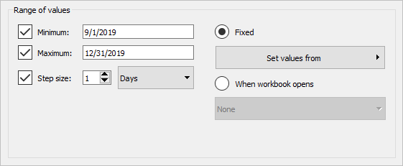
In this case, to refresh the parameter’s list of values (or domain) whenever the workbook opens, select List, and then select When workbook opens. Notice that the list of values on the left is grayed out because the workbook is dynamically pulling values from the data source.
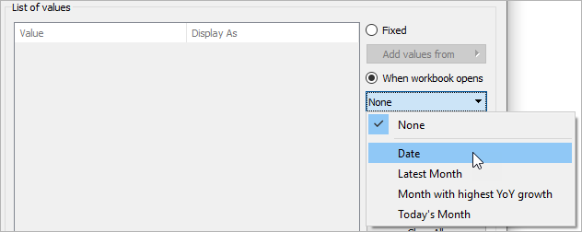
- When finished, click OK.
The parameter is now listed in the Parameters section at the bottom of the Data pane.
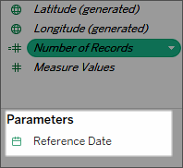

Steps to create do split
1. On the Data Source page, check the menu for Split and Custom Split.
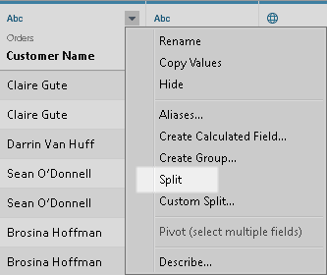
- From the Data pane on a sheet, check the menu for Transform > Split and Custom Split.
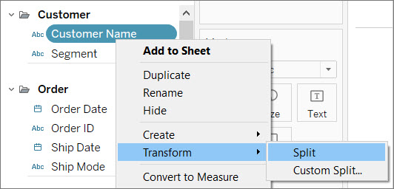

Pivot :

Adding pivot
Step 1 > Connect the "play_store_Data_Set.xlsx" data set.

Step 2 > Select the column and Right-click on the top left option and select Pivot.
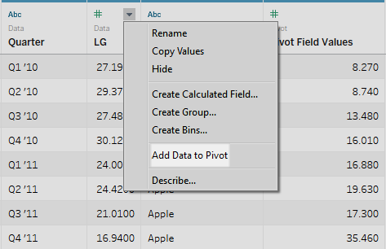
Step 3 > Change name from Pivot Names to cba.

Step 4 > Change name from Pivot Values to dgf.

Step 5 > Drag the column dimension and drop it onto the row shelf.

Step 6 > Drag the column measure and drop it onto the rows shelf right side of the column dimension.

Step 7 > Drag the column measure and put it into visualization at the corner.

Creating a Dashboard
To create a dashboard, we need to click on the “New Dashboard” button at the bottom. The button has a box shape with a plus sign.
First select the “Create New Dashboard” option from the menu, or just click on the Dashboard button in the bottom menu.
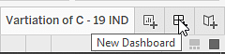
The next screen will be inside the dashboard window that looks like the following image.
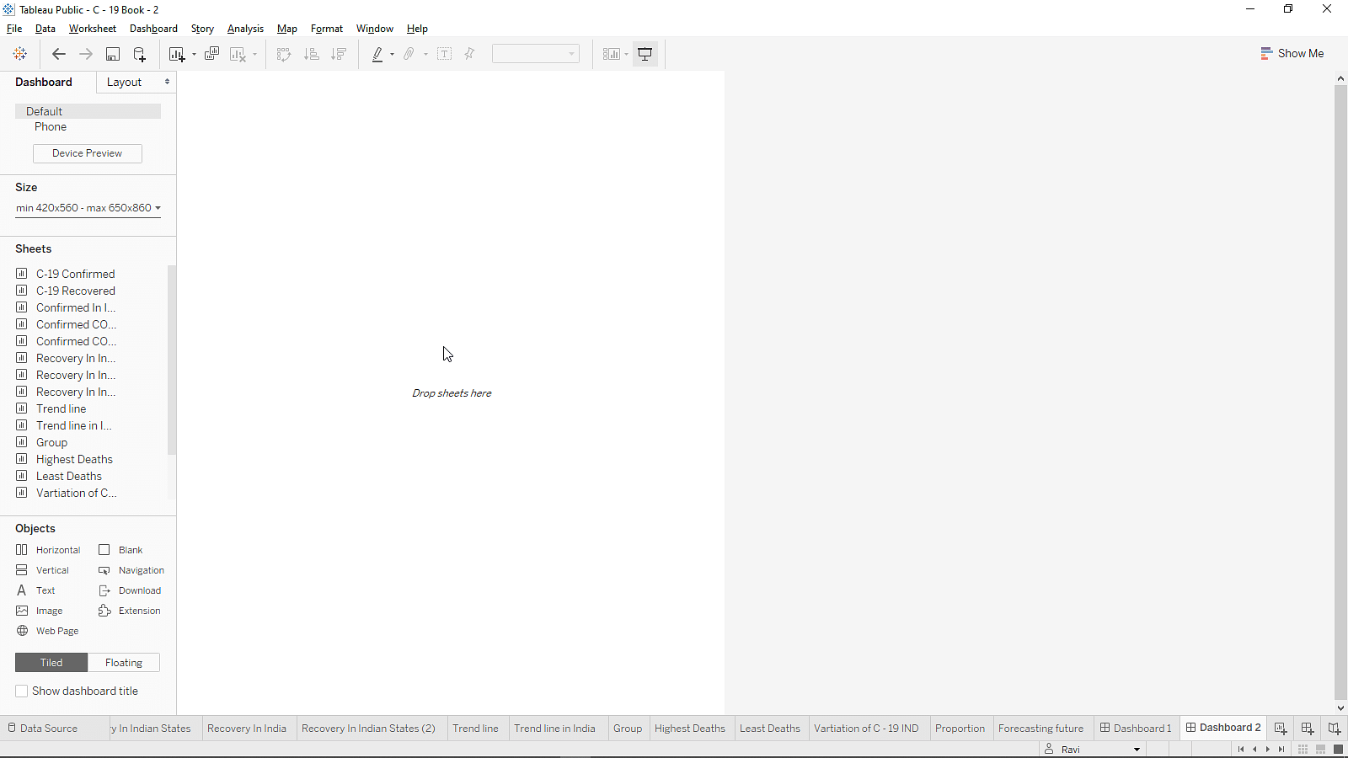
On the left-hand side, the worksheet visualization created will now be available. Creating a Tableau Dashboard is simple, just drag and drop the worksheets onto the Dashboard Canvas.
The left-hand panel of the dashboard provides you with various options for setting the presentation screen according to the device. The screen size can be manually set as well.
We can add interactivity to dashboards to enhance users' data insights. Try these techniques:
In the upper corner of sheet, enable the Use as Filter option to use selected marks in the sheet as filters for other sheets in the dashboard.
When authoring in Tableau Desktop, add actions to use multiple sheets as filters, navigate from one sheet to another, display web pages, and more.
Results and Discussion

Visualization Results:

Treemap Visualization: The treemap provides an intuitive overview of app categories and subcategories within the Google Play Store dataset. Categories such as "Games," "Tools," and "Entertainment" are visually represented, with subcategories nested within them.

Bubble Chart: The bubble chart visually depicts the relationship between user ratings, the number of reviews, and app installations. Bubbles of varying sizes and colors indicate different apps, with size representing review count, color indicating user rating, and position showing the number of installations.

Line Chart: The line chart tracks changes in app metrics (e.g., ratings, installs) over time, offering insights into trends and seasonality.

Box Plot: Box plots provide a detailed view of data distribution within categories or subcategories. They include key statistics such as the median, quartiles, and potential outliers for metrics like app ratings.

Discussion:

Tree map Visualization: The tree map immediately reveals the hierarchical structure of the dataset and the distribution of apps across categories. This information helps stakeholders quickly understand how apps are organized within the store.

Bubble Chart: The bubble chart is a powerful tool for identifying trends in user engagement and app popularity. It confirms that higher-rated apps tend to have more reviews and installations, suggesting a strong correlation between user ratings and popularity.

Line Chart: Temporal analysis from the line chart reveals how app metrics have evolved over months or years. Insights from this analysis can inform strategic decisions related to app releases and marketing campaigns.

Box Plot: Box plots are instrumental in understanding the spread of data points. They help identify categories or subcategories with rating distributions that deviate significantly from the norm. Outliers in the box plots may represent exceptional apps with unique characteristics worth exploring further.

Category Insights: Beyond the treemap, this section delves deeper into category dynamics, potentially identifying specific subcategories that dominate in terms of user ratings, downloads, or other metrics. This understanding informs category-based strategies.

User Behavior Analysis: User behavior analysis confirms that higher-rated apps tend to attract more reviews and installations. This insight guides developers and marketers in focusing on improving user ratings as a key strategy.

Temporal Trends: Temporal trends can be indicative of seasonality or evolving user preferences. Insights from this analysis assist in optimizing app release schedules and marketing strategies.

Outlier Detection: Identifying outliers through box plots can lead to the discovery of exceptional apps that stand out from the rest. Investigating these outliers provides valuable insights into factors contributing to their unique performance.

Actionable Insights: The insights derived from these visualizations offer actionable recommendations for app developers and marketers. Prioritizing categories with high user engagement, improving app ratings, and leveraging seasonal trends become key strategies based on the findings.

Data Storytelling: To effectively communicate these insights, the visualizations can be woven into a compelling data story or presentation, enabling stakeholders to grasp the nuances of the dataset and make informed decisions.

In summary, the combination of visualizations provides a comprehensive view of the Google Play Store Apps dataset, offering valuable insights that can shape strategies and decisions in the competitive mobile app market.

Conclusion

In this project, I have embarked on a data-driven journey into the expansive landscape of Google Play Store Apps. Leveraging the power of data visualization through tree maps, bubble charts, line charts, and box plots in Tableau, we uncovered valuable insights that provide a deeper understanding of app categories, user behavior, temporal trends, and exceptional outliers.

Our findings reveal that the Google Play Store is a dynamic ecosystem with diverse app categories and subcategories. The treemap visualization offered a bird's-eye view, making it easy to grasp the hierarchical structure of apps, allowing for swift category assessment.

User behavior analysis, facilitated by the bubble chart, affirmed a significant correlation between user ratings, reviews, and app installations. Higher-rated apps tend to garner more user engagement, a critical insight for developers and marketers seeking to enhance app performance.

Box plots provided an in-depth perspective, identifying categories and subcategories with exceptional rating distributions, helping us recognize outliers worth further exploration. These outliers are key to understanding what sets certain apps apart in terms of user reception.

Through actionable insights derived from our analyses, developers and marketers can make informed decisions. Prioritizing categories with high user engagement, improving app ratings, and capitalizing on seasonal trends become strategic imperatives.

In a rapidly evolving mobile app landscape, the ability to extract and interpret data-driven insights is invaluable. Our project demonstrates the power of data visualization and storytelling, not just as tools for analysis but as mediums for conveying compelling narratives that drive decision-making.

As we conclude this journey through Google Play Store Apps, we acknowledge that data-driven analysis is an ongoing process, continuously adapting to shifts in user preferences and market dynamics. Armed with the insights gleaned from our visualizations, stakeholders are better equipped to navigate the ever-changing terrain of the mobile app ecosystem and make informed choices for success.

